# Comprehensive Digital Marking for south Indian Bank?

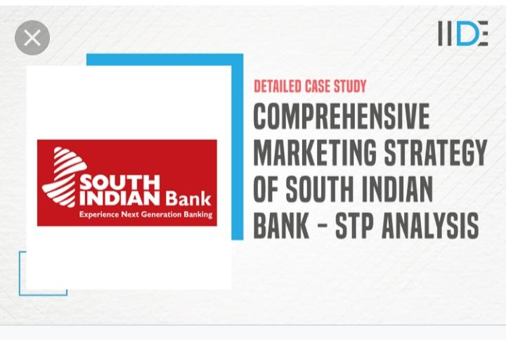

Creating a comprehensive digital marketing strategy for South Indian Bank involves understanding the bank's objectives, target audience, competitive landscape, and the right platforms to use. A successful strategy should combine brand-building, lead generation, customer engagement, and conversions. Here’s a detailed digital marketing approach for South Indian Bank.

1. Goals and Objectives

Before diving into specific channels and campaigns, it’s essential to define clear goals:

Brand Awareness: Enhance the visibility of South Indian Bank in the digital space.

Lead Generation: Drive potential customers to open new accounts, avail loans, or use other financial services.

Customer Engagement: Increase interaction and communication with customers, existing and potential.

Customer Retention: Strengthen customer loyalty by providing value through services and content.

2. Target Audience

Identifying the right audience is key to any successful marketing strategy:

Demographics: Focus on both urban and semi-urban populations across South India and beyond, ranging from millennials to older adults.

Psychographics: People looking for reliable banking solutions, tech-savvy individuals, businesses, students, and professionals interested in loans, savings, insurance, and investments.

Geography: South India initially (Kerala, Tamil Nadu, Karnataka, Andhra Pradesh, Telangana), but expansion to other regions can be considered.

3. Digital Marketing Channels

Website Optimization and SEO:

Ensure that the website is optimized for both desktop and mobile devices.

Use Search Engine Optimization (SEO) to target keywords like "Best bank in South India," "Low-interest personal loans," and "Digital banking services."

Create relevant content, blogs, and FAQs around personal finance, loans, investments, etc.

Social Media Marketing:

South Indian Bank should have an active presence across various social media platforms, such as:

Facebook: Regular posts on offers, news, and services; Live Q&A sessions with financial experts.

Instagram: Visual content showcasing bank offers, behind-the-scenes, customer success stories, and promotions.

Twitter: Real-time updates on banking policies, financial tips, and interacting with customers.

LinkedIn: Engage with professionals, showcasing case studies, and publishing articles related to business banking solutions.

Google Ads & PPC (Pay-Per-Click):

Run targeted ads for specific banking products (personal loans, savings accounts, etc.) using Google Ads. Use Display Network and Search Ads to target specific audiences looking for financial services.

Email Marketing:

Use segmented email campaigns to send personalized offers, account alerts, and loan reminders. Keep the communication engaging and valuable.

Monthly newsletters with updates, tips, and relevant financial advice.

Automated campaigns for new account holders, loan applicants, or other services.

Content Marketing:

Blogs/Articles: Focus on topics like financial literacy, saving tips, and how to choose the right loan or insurance. Ensure content is optimized for search engines.

Videos: Create explainer videos for banking products, how-to guides, and customer testimonials to build trust.

Infographics: Use visuals to explain complex topics like investment options or loan procedures.

Influencer and Affiliate Marketing:

Partner with financial bloggers or influencers who can promote South Indian Bank’s services and products on platforms like Instagram, YouTube, or blogs.

Work with local influencers in Southern India to build regional trust.

Online Reputation Management (ORM):

Manage and respond to online reviews on platforms like Google Reviews, Trustpilot, and social media. Positive customer reviews and transparent customer service help build trust.

Mobile Marketing and App Push Notifications:

Engage users via the South Indian Bank mobile app through push notifications about offers, updates, and personalized financial tips. Encourage app usage with incentives (e.g., no-fee for online transactions).

4. Paid Advertising Strategies

Google Ads & Search Engine Marketing (SEM):

Invest in paid ads for specific services like personal loans, home loans, or savings accounts to increase visibility in search results.

Target Local Keywords: "Best bank for savings accounts in Kochi," "Instant loan approval in Chennai," etc.

Use dynamic search ads and retargeting techniques.

Facebook/Instagram Ads:

Use targeted ads to segment potential customers based on location, interests, and demographic data.

Lead Generation Ads: Directly collect potential customer data for opening accounts or applying for loans.

Carousel Ads: Showcase multiple banking products in a single ad.

Video Ads on YouTube:

Use short video ads promoting new services, offers, or customer experiences. Also, run YouTube video ads on relevant channels related to finance, investment, or business.

5. Customer Support and Engagement

Chatbots for Instant Support:

Implement AI-driven chatbots on the website and app to answer customer queries related to banking products, account balance, and loan queries.

Live Webinars and Q&A Sessions:

Host online events where financial experts from the bank can address customer queries on loans, investments, and banking.

Interactive Content:

Create interactive quizzes, polls, or calculators to help customers understand the best products for their needs (e.g., loan eligibility calculator, tax-saving calculator, etc.).

6. Loyalty and Retention Programs

Referral Programs:

Launch referral campaigns encouraging existing customers to refer new customers to the bank by offering incentives such as fee waivers or cashback.

Reward Programs:

Introduce loyalty programs for long-term customers with rewards like bonus interest on savings accounts or discounts on loans.

Gamification:

Incorporate gamified elements in banking apps, where users can earn points for transactions, bill payments, or achieving savings goals.

7. Analytics and Optimization

Regularly analyze and optimize digital marketing efforts using tools such as:

Google Analytics to track website traffic, user behavior, and conversion rates.

Social Media Insights to gauge post performance and engagement on platforms like Facebook and Instagram.

A/B Testing for PPC campaigns, landing pages, and email campaigns to improve performance.

8. Partnerships and Collaborations

Consider forming strategic partnerships with other brands or institutions:

Corporate Partnerships: Collaborate with employers for payroll management and corporate banking services.

Influencer Partnerships: Work with local influencers for more localized and personal branding.

9. Compliance and Security

Ensure all digital marketing efforts comply with financial industry regulations, particularly around Data Privacy, KYC, and Anti-Money Laundering policies. All communication should maintain a sense of trustworthiness and transparency.

Conclusion

The digital marketing strategy for South Indian Bank should blend traditional banking values with innovative digital marketing techniques to provide excellent customer experience and engagement. By leveraging SEO, social media, content marketing, and paid ads, the bank can build a strong online presence and attract a loyal customer base.

# BRAND study competitor Analysis Buyers Audience's persona?

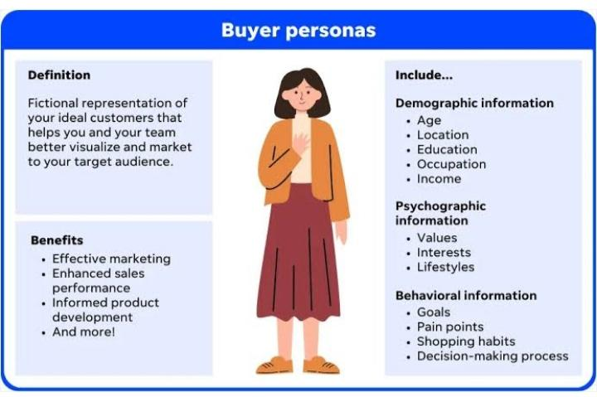

To conduct a thorough Brand Study, Competitor Analysis, and Buyers/Audience Persona research, we can break it down into a few core areas:

1. Brand Study

A brand study helps in understanding your brand's position in the market, its value proposition, identity, and how it resonates with customers.

Key Components:

Brand Identity: What are the core values, mission, and vision of the brand? What makes the brand unique?

Brand Awareness: How well is your brand known in the market? What is the perception of the brand among consumers?

Brand Positioning: Where does your brand stand in the market in terms of pricing, quality, and differentiation compared to competitors?

Brand Messaging: What are the key messages communicated through your branding efforts (taglines, content, etc.)?

Brand Loyalty: How loyal are your customers to the brand? Do you have a customer retention strategy in place?

Brand Communication: How does your brand communicate with customers through advertising, social media, and other channels?

Data Sources:

Customer feedback, surveys, and reviews

Social media monitoring

Website analytics and user behavior data

Internal brand guidelines and past marketing campaigns

2. Competitor Analysis

Competitor analysis helps you understand the strengths and weaknesses of your competitors, identify market gaps, and better position your brand.

Key Steps:

Identify Key Competitors: List direct and indirect competitors. Direct competitors are those offering similar products/services, while indirect competitors may offer substitutes.

Analyze Competitors' Products/Services: How do their offerings compare to yours in terms of quality, features, pricing, and innovation?

SWOT Analysis: Analyze each competitor's Strengths, Weaknesses, Opportunities, and Threats.

Market Positioning: How do competitors position themselves in the market in terms of pricing, messaging, and target audience?

Marketing Strategies: What are their marketing tactics? Are they using influencer marketing, content marketing, or social media? What platforms are they active on?

Customer Perception: Analyze online reviews, feedback, and sentiment about competitors' products/services.

Tools for Competitor Analysis:

SEMrush or Ahrefs (for website performance, traffic, and SEO comparison)

SpyFu (for competitive keyword analysis)

Social media platforms (for brand engagement and customer sentiment)

SimilarWeb (for overall digital presence comparison)

3. Buyer/Audience Persona

A buyer or audience persona is a detailed description of your ideal customers. Understanding your audience helps in crafting targeted marketing campaigns, improving product development, and enhancing customer experience.

Key Elements to Develop Personas:

Demographics: Age, gender, income, education, job title, location, etc.

Psychographics: Interests, values, attitudes, and lifestyle choices that influence buying behavior.

Pain Points: What are the key challenges or problems your target audience is facing that your product or service solves?

Buying Behavior: How do they make purchase decisions? Do they research products online, rely on recommendations, or prefer in-store shopping?

Goals and Motivations: What motivates them to buy? Are they driven by price, quality, convenience, brand loyalty, or social influence?

Preferred Communication Channels: Do they prefer email, social media, phone calls, or face-to-face communication?

Steps to Create Personas:

1. Conduct customer surveys and interviews.

2. Analyze your existing customer data (age, location, purchase history).

3. Use social media and website analytics to understand your audience's behavior.

4. Segment customers based on common characteristics and behaviors.

5. Create multiple personas for different audience segments (e.g., young professionals, parents, budget-conscious buyers).

Tools for Persona Development:

Google Analytics (for demographic and behavior data)

Typeform or SurveyMonkey (for surveys)

Facebook Audience Insights (for social media audience data)

---

Example:

Let’s say your brand is an eco-friendly skincare company. Here's how each step could look in practice:

1. Brand Study:

Identity: Eco-conscious, sustainable, cruelty-free, natural skincare solutions.

Positioning: Premium skincare solutions with a focus on sustainability and ethical sourcing.

Loyalty: High customer loyalty among eco-conscious consumers.

Communication: Through eco-focused storytelling on Instagram and YouTube.

2. Competitor Analysis:

Competitors: Companies like "Lush" (direct competitor), "Dr. Bronner's" (indirect competitor).

Strengths: Lush has a strong brand identity, highly engaging social media presence.

Weaknesses: Dr. Bronner's is less personalized in its customer engagement, though strong in ethical branding.

Opportunities: Gaps in providing premium organic skincare with superior customer service.

Threats: Established competitors have larger marketing budgets and a wider retail presence.

3. Buyer Persona:

Persona 1: “Eco-conscious Emma”

Demographics: Female, aged 25-35, mid-to-high income, urban living.

# Research Brand Identity?

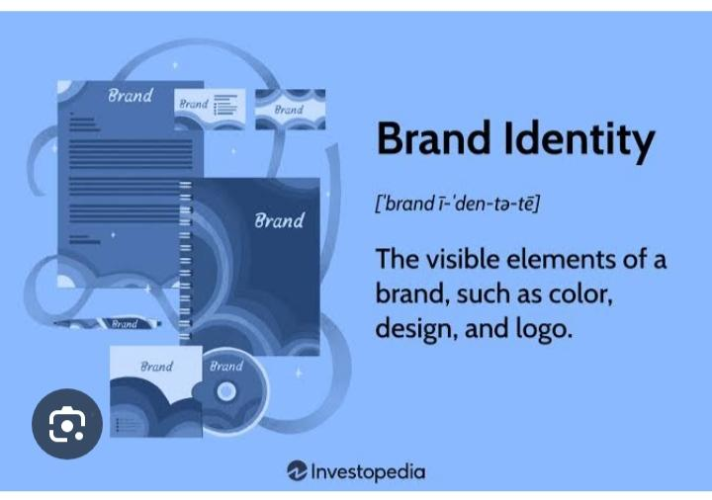

Brand identity refers to the visual, emotional, and cultural elements that define a brand and distinguish it from others. Here's a breakdown of the key components:

I. Visual Identity

1. *Logo*: The symbol or wordmark that represents the brand.

2. *Color Palette*: The selection of colors used to convey the brand's personality.

3. *Typography*: The fonts and font styles used to communicate the brand's message.

4. *Imagery*: The style and tone of images used to represent the brand.

II. Emotional Identity

1. *Tone of Voice*: The language and tone used to communicate with customers.

2. *Personality*: The human-like qualities that define the brand's character.

3. *Values*: The principles and beliefs that guide the brand's decisions.

4. *Mission Statement*: The statement that defines the brand's purpose.

III. Cultural Identity

1. *Brand Heritage*: The brand's history and legacy.

2. *Brand Positioning*: The brand's unique place in the market.

3. *Target Audience*: The demographics, needs, and preferences of the brand's ideal customer.

4. *Competitive Landscape*: The analysis of competitors and market trends.

IV. Brand Identity Elements

1. *Brand Guidelines*: The document that outlines the rules for using the brand's visual identity.

2. *Brand Messaging*: The core messages that communicate the brand's value proposition.

3. *Brand Storytelling*: The narrative that conveys the brand's history, values, and mission.

4. *Brand Experience*: The sum of all interactions between the customer and the brand.

V. Benefits of Strong Brand Identity

1. *Differentiation*: A unique brand identity sets the brand apart from competitors.

2. *Recognition*: A consistent brand identity builds recognition and familiarity.

3. *Trust*: A strong brand identity establishes trust and credibility with customers.

4. *Loyalty*: A well-crafted brand identity fosters loyalty and advocacy.

VI. Challenges in Building Brand Identity

1. *Consistency*: Maintaining a consistent brand identity across all channels.

2. *Authenticity*: Ensuring the brand identity is genuine and reflective of the brand's values.

3. *Relevance*: Keeping the brand identity relevant and up-to-date with changing market trends.

4. *Scalability*: Scaling the brand identity as the business grows and expands.

By understanding these components and challenges, you can develop a strong brand identity that resonates with your target audience and sets your brand apart from competitors.

# Competitor Analysis?



Brand identity refers to the visual, emotional, and cultural elements that define a brand and distinguish it from others. Here's a breakdown of the key components:

I. Visual Identity

1. *Logo*: The symbol or wordmark that represents the brand.

2. *Color Palette*: The selection of colors used to convey the brand's personality.

3. *Typography*: The fonts and font styles used to communicate the brand's message.

4. *Imagery*: The style and tone of images used to represent the brand.

II. Emotional Identity

1. *Tone of Voice*: The language and tone used to communicate with customers.

2. *Personality*: The human-like qualities that define the brand's character.

3. *Values*: The principles and beliefs that guide the brand's decisions.

4. *Mission Statement*: The statement that defines the brand's purpose.

III. Cultural Identity

1. *Brand Heritage*: The brand's history and legacy.

2. *Brand Positioning*: The brand's unique place in the market.

3. *Target Audience*: The demographics, needs, and preferences of the brand's ideal customer.

4. *Competitive Landscape*: The analysis of competitors and market trends.

IV. Brand Identity Elements

1. *Brand Guidelines*: The document that outlines the rules for using the brand's visual identity.

2. *Brand Messaging*: The core messages that communicate the brand's value proposition.

3. *Brand Storytelling*: The narrative that conveys the brand's history, values, and mission.

4. *Brand Experience*: The sum of all interactions between the customer and the brand.

V. Benefits of Strong Brand Identity

1. *Differentiation*: A unique brand identity sets the brand apart from competitors.

2. *Recognition*: A consistent brand identity builds recognition and familiarity.

3. *Trust*: A strong brand identity establishes trust and credibility with customers.

4. *Loyalty*: A well-crafted brand identity fosters loyalty and advocacy.

VI. Challenges in Building Brand Identity

1. *Consistency*: Maintaining a consistent brand identity across all channels.

2. *Authenticity*: Ensuring the brand identity is genuine and reflective of the brand's values.

3. *Relevance*: Keeping the brand identity relevant and up-to-date with changing market trends.

4. *Scalability*: Scaling the brand identity as the business grows and expands.

By understanding these components and challenges, you can develop a strong brand identity that resonates with your target audience and sets your brand apart from competitors.

# Buyers Audience's persona?

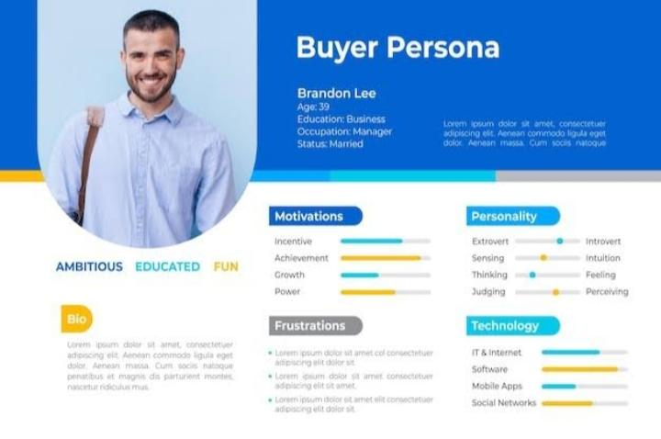

A buyer persona, also known as a customer or marketing persona, is a research-based profile that depicts a target customer. It describes who your ideal customers are, what their days are like, the challenges they face, and how they make decisions ¹.

Creating a buyer persona helps businesses understand and empathize with their customers, ensuring that all activities involved in acquiring and serving them are tailored to their needs. This can lead to better marketing strategies, improved product development, and increased customer satisfaction.

A typical buyer persona includes demographic information, interests, behaviors, goals, and pain points. For example, a buyer persona might look like this:

- *Name*: Samantha Smith

- *Age*: 35

- *Location*: New York City

- *Occupation*: Marketing Manager

- *Goals*: Looking for high-quality, stylish, and eco-conscious products

- *Pain Points*: Busy, overwhelmed by options, values convenience and responsibility ²

To create a buyer persona, you'll want to gather data through market research, surveys, and customer interviews. Identify common characteristics, demographics, behaviors, and goals of your target audience to develop a detailed profile ³.

# SEO & keyboard research?

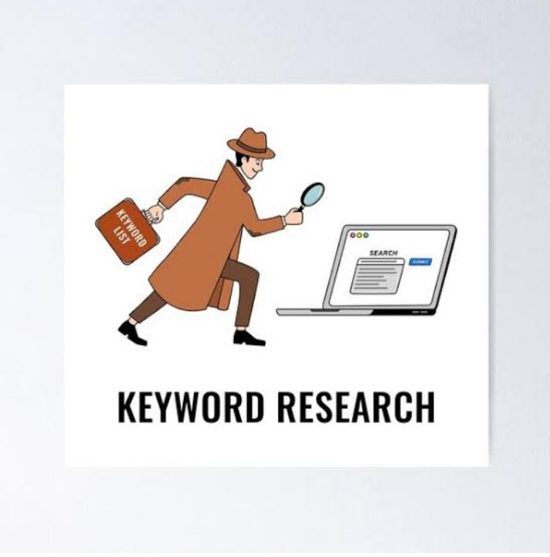

SEO keyword research is the process of identifying and selecting relevant keywords and phrases that your target audience uses to search for information, products, or services like yours.

I. Importance of Keyword Research

1. *Understanding Target Audience*: Keyword research helps you understand what your target audience is searching for.

2. *Relevant Content Creation*: Keyword research guides content creation to ensure relevance and usefulness to your audience.

3. *Improved Search Engine Rankings*: Targeting the right keywords can improve your website's visibility and ranking on search engines.

4. *Increased Website Traffic*: By targeting relevant keywords, you can attract more qualified leads and drive traffic to your website.

II. Keyword Research Tools

1. *Google Keyword Planner*: A free tool that helps you find keywords and get traffic estimates.

2. *Ahrefs*: A comprehensive tool that offers keyword research, backlink analysis, and content analysis.

3. *SEMrush*: A tool that provides keyword research, competitor analysis, and technical SEO audits.

4. *Moz Keyword Explorer*: A tool that offers keyword research, competitor analysis,

# SEO Audit?



An SEO audit is a comprehensive analysis of a website's search engine optimization (SEO) performance. It aims to identify areas of improvement to increase the website's visibility, drive more traffic, and boost conversions.

Here's a breakdown of what an SEO audit typically includes:

Technical SEO

1. *Crawlability and indexing*: Ensuring search engines can crawl and index the website's pages.

2. *Website speed and performance*: Analyzing page load times, mobile responsiveness, and browser caching.

3. *SSL encryption and security*: Verifying the presence of an SSL certificate and ensuring the website is secure.

4. *XML sitemap and robots.txt*: Checking the existence and correctness of these files.

On-Page SEO

1. *Keyword research and optimization*: Identifying relevant keywords and assessing their usage in content, meta tags, and headings.

2. *Content quality and uniqueness*: Evaluating the quality, uniqueness, and relevance of the website's content.

3. *Meta tags and titles*: Reviewing the accuracy, completeness, and optimization of meta tags, titles, and descriptions.

4. *Header tags and structure*: Assessing the organization and hierarchy of content using header tags (H1, H2, H3, etc.).

Off-Page SEO

1. *Backlink analysis*: Examining the quality, quantity, and relevance of incoming links to the website.

2. *Local SEO (if applicable)*: Verifying the website's presence in local directories, Google My Business, and other local SEO elements.

3. *Social media presence*: Assessing the website's integration with social media platforms.

Analytics and Tracking

1. *Google Analytics setup*: Verifying the correct installation and configuration of Google Analytics.

2. *Goal tracking and conversion rates*: Analyzing the setup and performance of goals, events, and conversion rates.

Recommendations and Implementation

After the audit, you'll receive a report outlining the findings, recommendations, and prioritized action items to improve the website's SEO performance.

Would you like me to elaborate on any specific aspect of an SEO audit?

# Keyword research?



Keyword research is a crucial step in search engine optimization (SEO), content marketing, and pay-per-click (PPC) advertising. Here's a comprehensive overview:

Why Keyword Research Matters

1. *Understanding your audience*: Keyword research helps you identify what your target audience is searching for, allowing you to create relevant content.

2. *Improving search engine rankings*: By optimizing your content with relevant keywords, you can increase your chances of ranking higher in search engine results pages (SERPs).

3. *Driving targeted traffic*: Keyword research enables you to attract the right audience to your website, increasing the likelihood of conversions.

Types of Keywords

1. *Short-tail keywords*: Brief, generic terms with high search volume (e.g., "coffee").

2. *Long-tail keywords*: More specific phrases with lower search volume (e.g., "specialty coffee beans").

3. *Primary keywords*: Main keywords relevant to your business or content.

4. *Secondary keywords*: Related keywords that support your primary keywords.

Keyword Research Tools

1. *Google Keyword Planner*: A popular, free tool for finding keywords and estimating search volume.

2. *Ahrefs*: A comprehensive tool for keyword research, backlink analysis, and content optimization.

3. *SEMrush*: An all-in-one tool for keyword research, competitor analysis, and technical SEO audits.

4. *Moz Keyword Explorer*: A tool for keyword research, prioritization, and optimization.

Steps for Keyword Research

1. *Brainstorm seed keywords*: Identify initial keywords related to your business or content.

2. *Use keyword research tools*: Explore tools like Google Keyword Planner, Ahrefs, or SEMrush to find relevant keywords.

3. *Analyze competitors*: Research your competitors' websites and content to identify gaps and opportunities.

4. *Refine and prioritize keywords*: Filter and prioritize keywords based on relevance, search volume, and competition.

5. *Create content optimized for keywords*: Use your target keywords strategically in your content to improve search engine rankings and drive targeted traffic.

Would you like me to elaborate on any specific aspect of keyword research?

# On page Otimizition?



On-page optimization (OPO) is the process of optimizing individual web pages to rank higher in search engines and improve user experience. Here's a comprehensive checklist:

I. Keyword Optimization

1. *Keyword Research*: Conduct thorough keyword research to identify relevant keywords.

2. *Keyword Placement*: Use keywords strategically in:

- Page title

- Meta description

- Headings (H1, H2, H3, etc.)

- Body content

- Image alt tags

- Internal linking anchor text

II. Content Optimization

1. *High-Quality Content*: Create unique, informative, and engaging content.

2. *Content Length*: Ensure content is comprehensive and meets user needs (aim for 500-2,000 words).

3. *Content Format*: Use varied content formats, such as:

- Text

- Images

- Videos

- Infographics

- Podcasts

III. Meta Tags and Titles

1. *Page Title*: Write a unique, descriptive, and keyword-rich title (<60 characters).

2. *Meta Description*: Craft a compelling and informative meta description (<160 characters).

3. *Meta Keywords*: Use relevant and specific meta keywords (optional).

IV. Header Tags and Structure

1. *Header Tags*: Organize content using header tags (H1, H2, H3, etc.).

2. *Content Structure*: Use a logical and consistent content structure.

V. Image Optimization

1. *Image File Name*: Use descriptive and keyword-rich file names.

2. *Image Alt Tag*: Add alt tags that describe the image and include target keywords.

# Contact Creation and Curation?



Content creation and curation are crucial components of a successful content marketing strategy. Here's a comprehensive guide:

Content Creation

1. *Define Your Target Audience*: Understand who your ideal customer is, what their pain points are, and what type of content they engage with.

2. *Develop a Content Strategy*: Plan your content types, formats, and channels to ensure consistency and efficiency.

3. *Create High-Quality, Relevant Content*: Produce well-researched, engaging, and informative content that addresses your audience's needs.

4. *Use Visuals and Multimedia*: Incorporate images, videos, podcasts, and infographics to make your content more engaging and shareable.

5. *Optimize for SEO*: Use keywords strategically, optimize meta tags, and ensure mobile-friendliness to improve search engine rankings.

Content Curation

1. *Find Relevant, High-Quality Content*: Discover and collect relevant content from credible sources, such as industry leaders, news outlets, and research institutions.

2. *Use Content Curation Tools*: Leverage tools like Feedly, Pocket, or Curata to streamline content discovery and organization.

3. *Add Context and Insights*: Provide additional context, analysis, or commentary to make the curated content more valuable and relevant to your audience.

4. *Share Curated Content*: Distribute curated content through social media, email newsletters, or blog posts to engage your audience and establish thought leadership.

5. *Give Credit and Attribute Sources*: Always attribute the original source and give credit to the creators to maintain credibility and avoid plagiarism.

Types of Content

1. *Blog Posts*: In-depth articles on specific topics, often including industry insights, research, and analysis.

2. *Social Media Posts*: Short-form content, such as tweets, Facebook updates, or Instagram captions, used to engage and inform audiences.

3. *Videos*: Visual content, including explainer videos, tutorials, or vlogs, used to educate, entertain, or demonstrate products or services.

4. *Podcasts*: Audio content, often featuring interviews, discussions, or storytelling, used to engage and inform audiences.

5. *E-books and Whitepapers*: Comprehensive, in-depth guides on specific topics, often used for lead generation and thought leadership.

6. *Infographics*: Visual representations of data, information, or knowledge, used to communicate complex information in an engaging and shareable format.

Content Distribution Channels

1. *Social Media*: Facebook, Twitter, LinkedIn, Instagram, and other platforms used to share and engage with content.

2. *Email Newsletters*: Regularly sent emails containing curated content, news, or updates, used to nurture leads and build relationships.

3. *Blog*: A self-hosted or third-party platform used to publish and share content, often including articles, videos, and podcasts.

4. *Content Aggregators*: Platforms like Medium, LinkedIn Pulse, or Quora, used to share and discover content.

5. *Influencer Marketing*: Partnering with influencers to promote and distribute content to their followers.

Measuring Content Success

1. *Website Analytics*: Tools like Google Analytics used to track website traffic, engagement, and conversion metrics.

2. *Social Media Metrics*: Tracking engagement, reach, and clicks on social media platforms.

3. *Lead Generation*: Measuring the number of leads generated from content, such as e-book downloads or webinar registrations.

4. *Conversion Rates*: Tracking the percentage of leads that convert into customers or take a desired action.

5. *Return on Investment (ROI)*: Calculating the revenue generated by content compared to its production and distribution costs.

# Post Creation?



Here's a comprehensive guide to post creation:

I. Types of Posts

1. *Informative Posts*: Share valuable information, insights, or expertise.

2. *Promotional Posts*: Promote products, services, or events.

3. *Engagement Posts*: Encourage interaction, ask questions, or spark discussions.

4. *Entertaining Posts*: Share humorous, relatable, or inspiring content.

5. *Educational Posts*: Share tutorials, how-to guides, or explain complex concepts.

II. Post Creation Process

1. *Define Your Objective*: Determine the purpose of your post (e.g., drive traffic, generate leads, boost engagement).

2. *Know Your Audience*: Understand who your target audience is, what they're interested in, and what type of content they engage with.

3. *Choose a Format*: Decide on the format of your post (e.g., text-only, image, video, infographic).

4. *Create Engaging Content*: Write attention-grabbing headlines, use compelling visuals, and craft informative and engaging content.

5. *Optimize for SEO*: Use relevant keywords, optimize meta tags, and ensure mobile-friendliness.

III. Visual Content

1. *Images*: Use high-quality, relevant images that enhance the content and grab attention.

2. *Videos*: Create engaging, informative, and entertaining videos that showcase products, services, or expertise.

3. *Infographics*: Design visually appealing and informative infographics that communicate complex information.

4. *GIFs*: Use GIFs to add humor, emphasize points, or illustrate complex concepts.

IV. Writing Style

1. *Conversational Tone*: Use a friendly, approachable tone that resonates with your audience.

2. *Clear and Concise Language*: Avoid jargon, use simple language, and break up long paragraphs.

3. *Storytelling*: Use narratives to make your content more relatable, memorable, and engaging.

4. *Humor*: Incorporate humor to lighten the mood, make your content more enjoyable, and build a connection with your audience.

V. Optimization and Publishing

1. *Meta Tags*: Optimize meta titles, descriptions, and keywords for SEO.

2. *Image Optimization*: Optimize image file names, alt tags, and descriptions.

3. *Internal Linking*: Link to relevant internal pages to enhance user experience and SEO.

4. *Publish and Promote*: Publish your post and promote it through social media, email newsletters, and other channels.

VI. Post Promotion

1. *Social Media*: Share your post on social media platforms to reach a wider audience.

2. *Email Newsletters*: Include your post in email newsletters to subscribers.

3. *Influencer Outreach*: Share your post with influencers in your niche to expand your reach.

4. *Paid Advertising*: Use paid advertising channels like Facebook Ads, Google AdWords, or LinkedIn Ads to promote your post.

# Social Media Ad Campaigns?

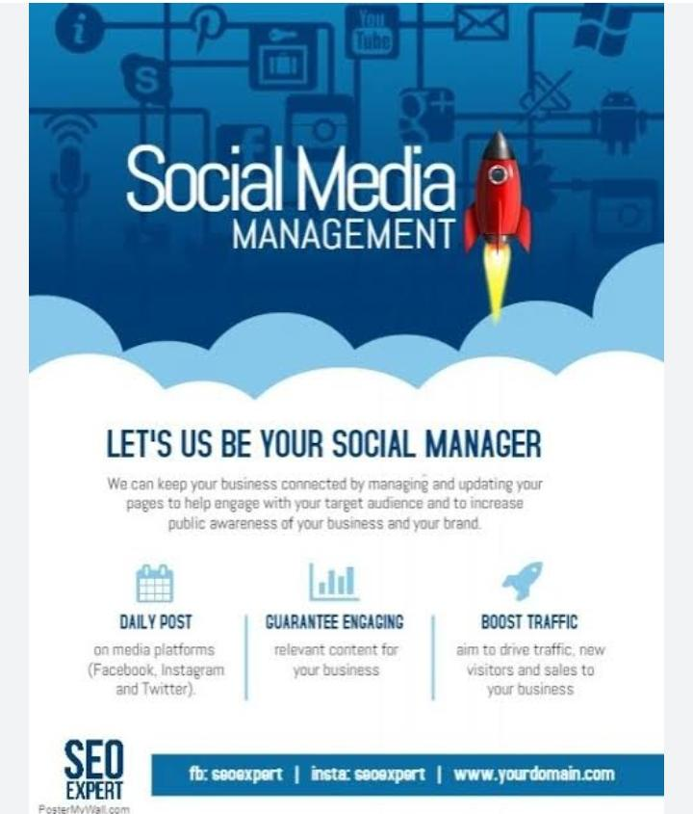

Social media ad campaigns are a powerful way to reach your target audience, increase brand awareness, and drive website traffic and sales. Here's a comprehensive guide:

I. Benefits of Social Media Ad Campaigns

1. *Targeted Advertising*: Reach specific demographics, interests, and behaviors.

2. *Increased Brand Awareness*: Build recognition and establish your brand identity.

3. *Website Traffic and Conversions*: Drive visitors to your website and convert them into customers.

4. *Cost-Effective*: Social media ads can be more affordable than traditional advertising methods.

II. Social Media Ad Platforms

1. *Facebook Ads*: Target specific audiences, interests, and behaviors.

2. *Instagram Ads*: Visually engaging ads for Instagram's 1 billion+ users.

3. *Twitter Ads*: Reach users based on keywords, interests, and hashtags.

4. *LinkedIn Ads*: Target professionals based on job title, industry, and company size.

5. *YouTube Ads*: Video ads for YouTube's vast audience.

III. Ad Formats

1. *Image Ads*: Static images with text overlays.

2. *Video Ads*: Video content with sound and motion.

3. *Carousel Ads*: Multiple images or cards in a single ad.

4. *Collection Ads*: Product catalogs with images and prices.

5. *Story Ads*: Full-screen, immersive ads for Instagram and Facebook.

IV. Targeting Options

1. *Demographic Targeting*: Age, location, language, and more.

2. *Interest Targeting*: Hobbies, interests, and behaviors.

3. *Lookalike Targeting*: Reach users similar to your existing customers.

4. *Custom Audiences*: Target users based on email lists, phone numbers, or user IDs.

V. Budgeting and Bidding

1. *Daily Budget*: Set a daily budget for your ad campaigns.

2. *Lifetime Budget*: Set a total budget for the duration of your campaign.

3. *Cost Per Click (CPC)*: Bid on the cost of each ad click.

4. *Cost Per Thousand Impressions (CPM)*: Bid on the cost of every 1,000 ad impressions.

VI. Measuring and Optimizing

1. *Conversion Tracking*: Monitor website conversions, sales, or leads.

2. *Ad Performance Metrics*: Track ad impressions, clicks, and engagement.

3. *Return on Ad Spend (ROAS)*: Measure revenue generated by ad campaigns.

4. *A/B Testing*: Test ad creative, targeting, and bidding strategies.

VII. Best Practices

1. *Clear Objectives*: Define specific campaign goals and metrics.

2. *High-Quality Ad Creative*: Use visually appealing images and compelling copy.

3. *Targeted Audience*: Use precise targeting options to reach your ideal audience.

4. *Regular Optimization*: Monitor and adjust campaigns to improve performance.

# Email ID Campaigns?

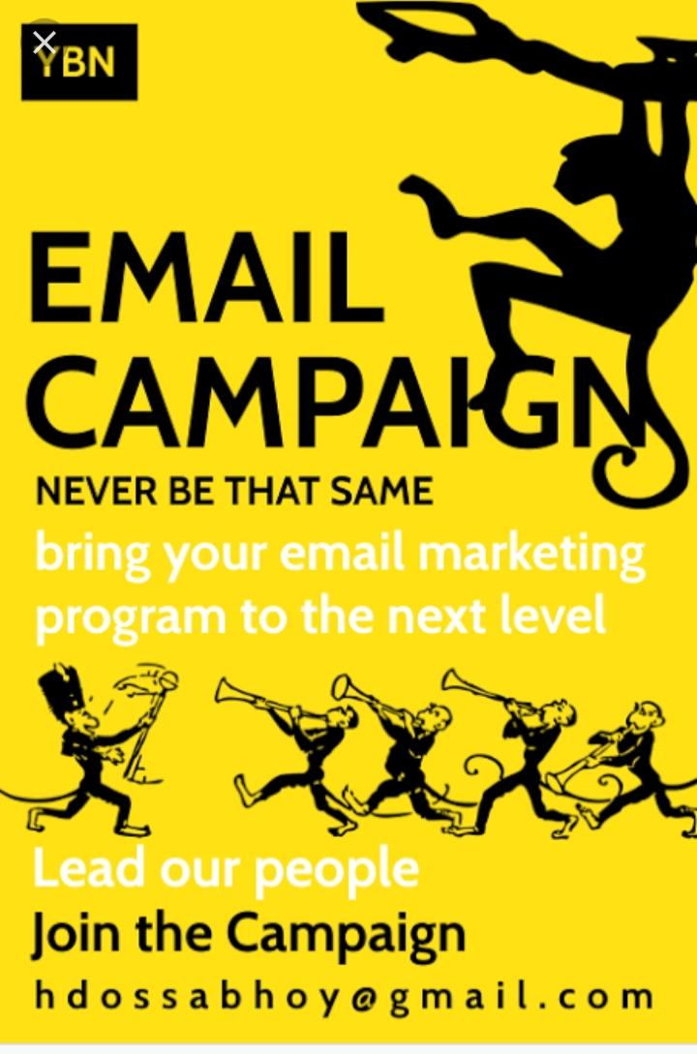

Email ad campaigns are a targeted and cost-effective way to reach your audience, build brand awareness, and drive conversions. Here's a comprehensive guide:

I. Benefits of Email Ad Campaigns

1. *Targeted Advertising*: Reach specific demographics, interests, and behaviors.

2. *Increased Brand Awareness*: Build recognition and establish your brand identity.

3. *High Conversion Rates*: Drive website traffic, generate leads, and convert sales.

4. *Cost-Effective*: Email ads can be more affordable than traditional advertising methods.

II. Email Ad Campaign Types

1. *Newsletters*: Regularly sent emails with news, updates, and promotions.

2. *Promotional Emails*: One-time emails with special offers, discounts, or announcements.

3. *Abandoned Cart Emails*: Targeted emails to customers who left items in their cart.

4. *Welcome Emails*: Initial emails to new subscribers or customers.

III. Email Ad Design

1. *Clear and Concise Subject Lines*: Grab attention and encourage opens.

2. *Visually Appealing Templates*: Use responsive, mobile-friendly designs.

3. *Compelling Copy*: Write engaging, persuasive, and concise content.

4. *Prominent Calls-to-Action (CTAs)*: Encourage clicks and conversions.

IV. Email Ad Targeting

1. *Segmentation*: Divide your email list into targeted groups based on demographics, behavior, or preferences.

2. *Personalization*: Use subscriber data to create personalized content and offers.

3. *Triggered Emails*: Send automated emails based on subscriber actions or milestones.

V. Email Ad Metrics and Optimization

1. *Open Rates*: Track the percentage of subscribers who open your emails.

2. *Click-Through Rates (CTRs)*: Monitor the percentage of subscribers who click on links.

3. *Conversion Rates*: Measure the percentage of subscribers who complete a desired action.

4. *Unsubscribe Rates*: Track the percentage of subscribers who opt-out of your emails.

5. *A/B Testing*: Test subject lines, content, CTAs, and targeting to improve performance.

VI. Email Ad Platforms

1. *Mailchimp*: A popular email marketing platform for small businesses.

2. *Constant Contact*: A comprehensive email marketing platform for businesses and organizations.

3. *Klaviyo*: A specialized email marketing platform for e-commerce businesses.

4. *Campaign Monitor*: A professional email marketing platform for businesses and agencies.

VII. Best Practices

1. *Clear and Concise Content*: Write engaging, easy-to-read content.

2. *Mobile-Friendly Designs*: Ensure emails are optimized for mobile devices.

3. *Segmented and Targeted*: Send relevant content to specific audience segments.

4. *Regularly Clean and Update Your List*: Remove inactive or unengaged subscribers.

5. *Comply with Email Marketing Regulations*: Follow laws like GDPR, CAN-SPAM, and CASL.